Connect to your jenkins terminal

cd /var/ lib/jenkins

ls

sudo vi config.xml

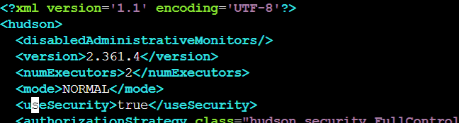

Change useSecurity value from **true** to **false**

**Then save the file & restart jenkins service (sudo service jenkins restart)**

**cat /var/jenkins_home/secrets/initialAdminPassword**